Remedy
Smart IT Work Order
User Basics

December 2016

Work Order Management Using Smart IT
A Work Order is an order received by an organization from a customer or client, or an order created internally within the organization.
At Cornell, we use work orders to request services or products whereas Incident Management is designed to deal with issues that need to be restored to normal functions.

If you would like to create a Work Order you can do so from the Smart Recorder or from the Create New pull down menu.

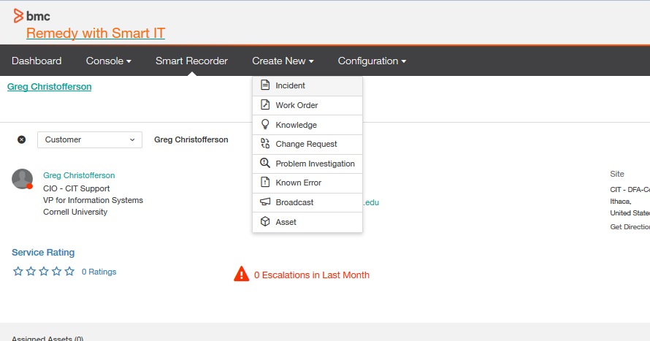

To see existing Work Orders, click on the Console > Ticket Console

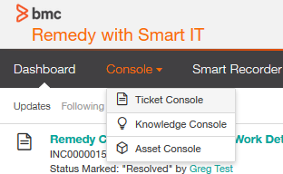

If you don’t see your work orders in your console view, you may have to add the filter to see them. To do this click on Filters and checking the box in front of Work Order

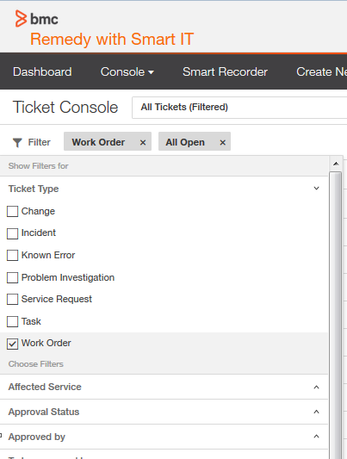

To view/edit a Work Order highlight the entry you would like to view/edit and double click.

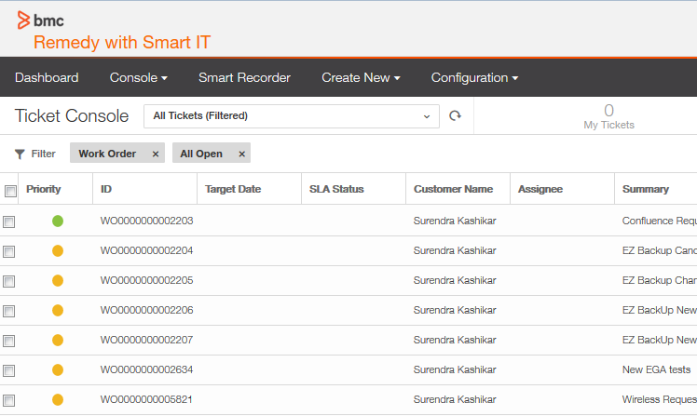

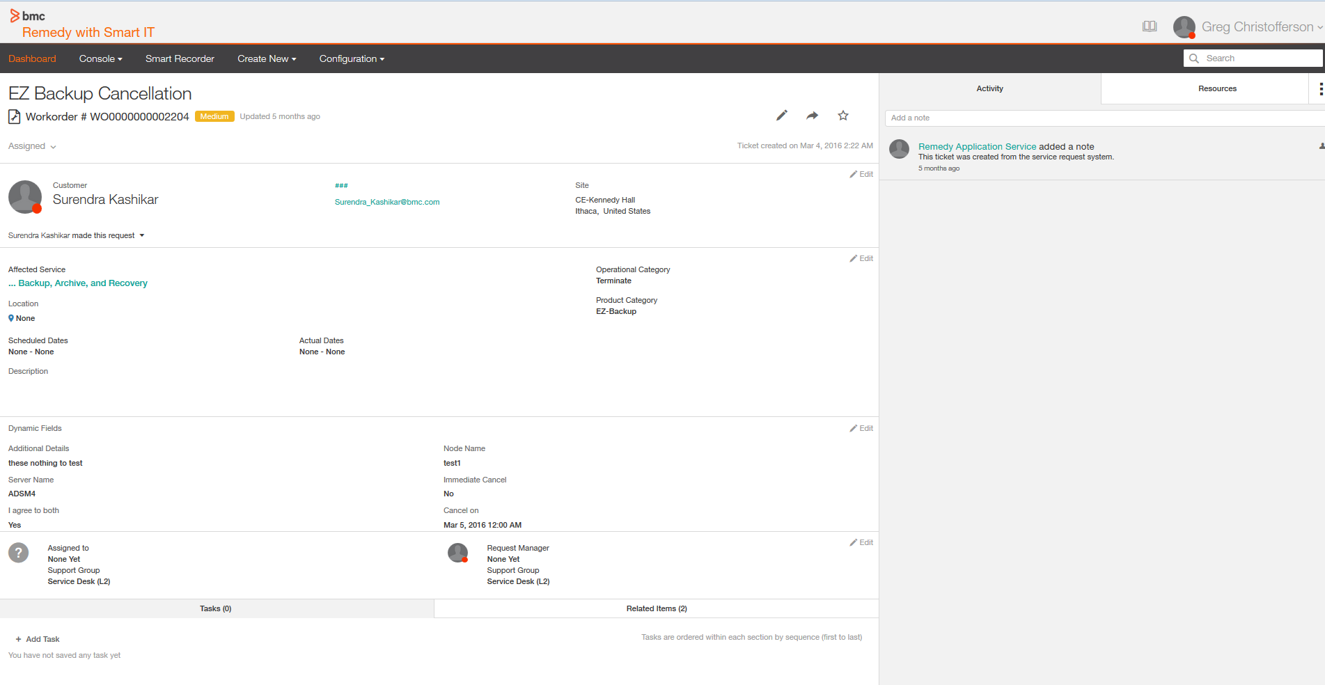

Creating a Work Order from “Smart Recorder” menu

Smart Recorder
Keyword Search Symbols
To help Smart Recorder recognize keywords on which it will run searches, type a special character in front of the keyword.
Symbol | What follows is…
@ | A person or an asset
! | A template

Smart Recorder uses a free-form text entry field to help you focus on what the customer is saying, instead of filling out fields in a structured form. This way of creating a ticket helps you to capture information in real time, directly from the customer and in their own words. Smart Recorder helps you to create tickets of all kinds more quickly and with greater accuracy.
- Click Smart Recorder in the Remedy toolbar.
When you open the Smart Recorder first time, the guidance text (“Begin by entering @person’s name, email, login ID or corporate ID and a description of the issue.”) prompts you on how to begin.
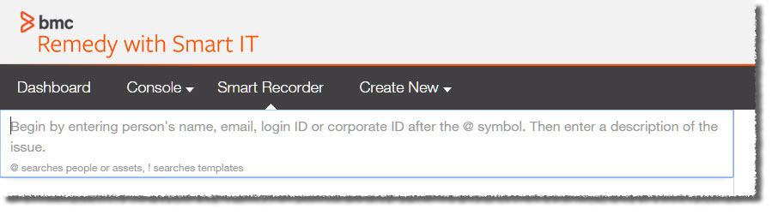
2.Beginning with the @ symbol and a letter, enter the beginning of the customer’s name, NetID, or email address, then select the customer from the list of all possible matches that pops up.
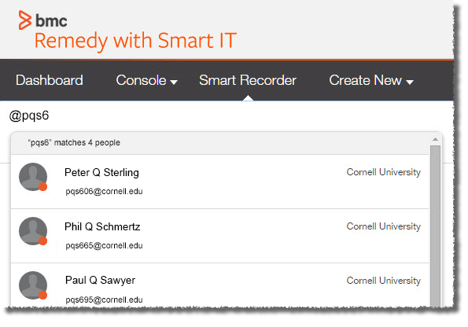
When the customer is matched, the customer preview area populates with the customer's contact information. Under the customer's information, you can also see the existing open tickets that involve current customer or asset.
(Optional) Identify additional people by using the @ symbol again. Using the menu next to each person's name, identify one (and only one) person as the customer, and all others as contacts or persons mentioned in the issue.
3. Start describing the issue by entering an issue type, term, or phrase. The system will search for suggested resources. Use the keyword search symbols to identify assets and templates.
If you know the service, you can add that in the toolbar as well by typing @servicename. The system will search for related services, cross-referenced with previously referenced people, locations, issues, or assets. This same rules apply for assets with @assetname.
Once you have entered the appropriate information for your request, click Create Ticket on the bottom right of the screen, you will be provided with two options, click Create Work Order.

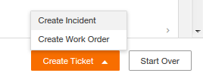

- Assignee and Request Manager are fields. If you are the Assignee or Request Manager Assignee, then you can click on the Assign to me link to auto-fill these values. If you are not going to be assigned to the work order, click Change Assignment
- From the Update Assignment window:
  - Click on Assignee
  - Choose Support Company, Support Organization and Support group.
  - A list of possible assignees will appear below. If you know the assignee, select the name. If you don’t know who the assignee should be, click Save and the ticket will be assigned to the support group

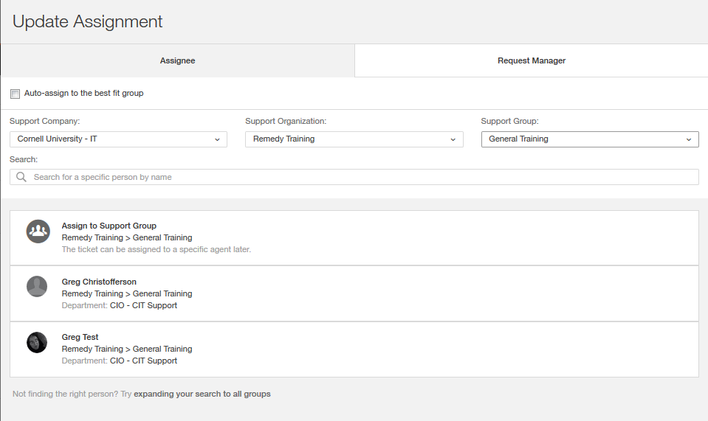

  - Click on Request Manager
  - Choose Support Company, Support Organization and Support group.
  - A list of possible assignees will appear below. If you know the assignee, select the name. If you don’t know who the assignee should be, click Save and the ticket will be assigned to the support group

- To select the Operational Category, you can either search (based on text you enter) or browse.
- Search: Enter part of the name of the desired Operational Category. You’ll be shown a list of categories that match what you have typed, with all tiers chained together. For example, Request > Hardware > Move. Select the appropriate match.

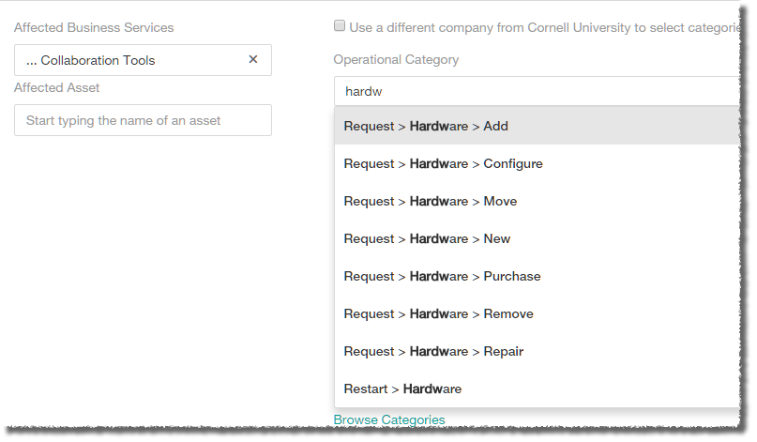

- Browse: Click Browse Categories. You’ll see three empty boxes, representing the three tiers of categorization. Click in the uppermost box to select the appropriate choice. Click in the second and third boxes to select the other tiers.
- At the bottom, click Save
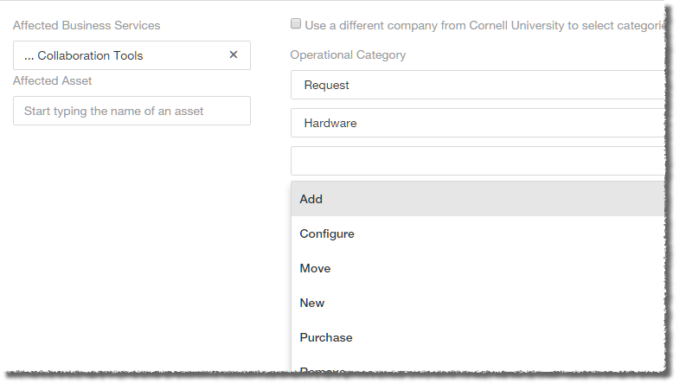

- Select the appropriate Product Category. As with Operational Categories, you can either search or browse.

Creating a Work Order from “Create New” menu

Universal/web-based client only
Using Smart IT, you can also create tickets from the Create New menu, as illustrated in the following scenario for creating an incident request. The Create New menu uses a more traditional, form based way to create tickets.
Using the Create New menu, you can create the following tickets and events:
- incident
- work order
- change request
- problem investigation
- broadcast
- knowledge
- known error
- asset

*NOTE: at this time Asset, Broadcast, Knowledge are not available.

The procedure below covers creating a Work Order, but the steps involved are nearly the same for other types of events.
- Open Smart IT.
- Click Create New, then select Work Order.
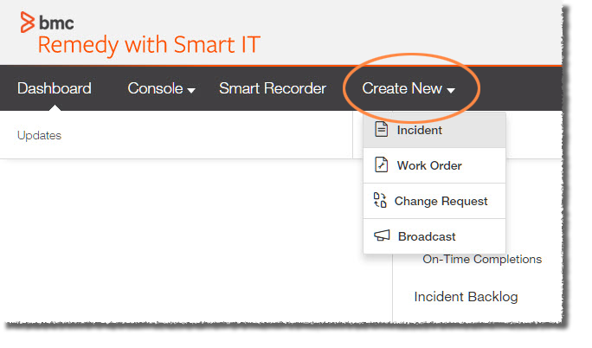
- In the Affected Customer(s) field, enter the beginning of the customer’s name, NetID, or email address, then select the customer from the list of all possible matches that pops up. The Affected Company field will auto-populate based on your selection.
- (optional) Click Add person to add additional customers.
- Enter the Work Order Title.
- Enter an Work Order Description.
- Set Priority if needed.
- Select the Work Order Status.
- Enter the beginning of the name of the Affected Business Service, then select the appropriate match.
All CIT service names start with three periods and a space. For example,
… Collaboration Tools and
… Training.
All generic service names start with four dashes and a space. For example,
---- Business Applications and
---- Web Design Services.
- Assignee and Request Manager are fields that are assigned to someone. If you are the Assignee or Request Manager Assignee, then you can click on the Assign to me link to auto-fill these values. If you are not going to be assigned to the work order, click Change Assignment
- From the Update Assignment window:
  - Click on Assignee
  - Choose Support Company, Support Organization and Support group.
  - A list of possible assignees will appear below. If you know the assignee, select the name. If you don’t know who the assignee should be, click Save and the ticket will be assigned to the support group

  - Click on Request Manager
  - Choose Support Company, Support Organization and Support group.
  - A list of possible assignees will appear below. If you know the assignee, select the name. If you don’t know who the assignee should be, click Save and the ticket will be assigned to the support group

- To select the Operational Category, you can either search (based on text you enter) or browse.
- Search: Enter part of the name of the desired Operational Category. You’ll be shown a list of categories that match what you have typed, with all tiers chained together. For example, Request > Hardware > Move. Select the appropriate match.

- Browse: Click Browse Categories. You’ll see three empty boxes, representing the three tiers of categorization. Click in the uppermost box to select the appropriate choice. Click in the second and third boxes to select the other tiers.
- At the bottom, click Save

- Select the appropriate Product Category. As with Operational Categories, you can either search or browse.
- Once you have updated these fields click Save

Work with Existing Work Orders
After you create a Work Order, you can change the details or add new information to it.
Keeping the information in a ticket up-to-date helps you to make better informed decisions about how to manage the ticket, keeps your personal and group statistics up-to-date, and helps keep the affected customer informed about the progress of the ticket.
Search for tickets by filtering and sorting tickets in the Console.
After you open ticket details, click the Pencil icon associated with a group of fields to open those fields in edit mode, which allows you to update the field contents.

Assign Work Orders
- After opening the detailed view of the ticket, click the Pencil icon in the Assigned to section. An Update Assignment pane will open, displaying the members of the currently selected group.
- You can select a different member of the same group from the list, or change the group assignment from the Group dropdown list.
- Click Save when finished.

Change Customer Information
This section mostly non-editable at this time, but we expect it to become editable in a future release.

Create Activity Entries
- After opening the detailed view of the ticket, you’ll see the Activities pane on the right.
- Click Add a note, then enter your text.
- Use the Type dropdown list to classify your note.
- To add an attachment, click or tap the paperclip icon, then select the desired file.
- Click Save when finished.

Add/View Attachments
- After opening the detailed view of the ticket, you’ll see the Activities pane on the right.
- Click or tap in the Add a note field.
- Click or tap the paperclip icon, then select the desired file.
- Click Save when finished.

Link Related Incidents
Information on other tickets or entities can help you to diagnose the ticket you are currently working on. You might also know of other existing tickets that in some way are related to the ticket that you are working on. Perhaps the ticket you are working was caused by a incident, or the work order that you are working on has caused an incident. When these types of relationships exist, you can create links among tickets so that others who are working with you to resolve the issue are aware of the broader context in which they are working, or can view information that can be helpful to them.
- After opening the detailed view of the work order, click the Related Items tab near the bottom of the record.
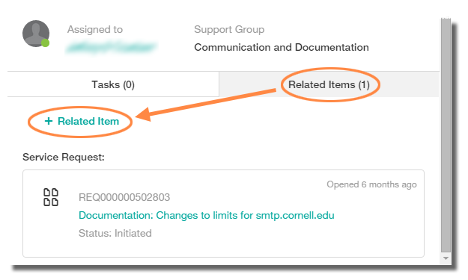
- Click + Related Item to add an item. A Relate Items pane will open.
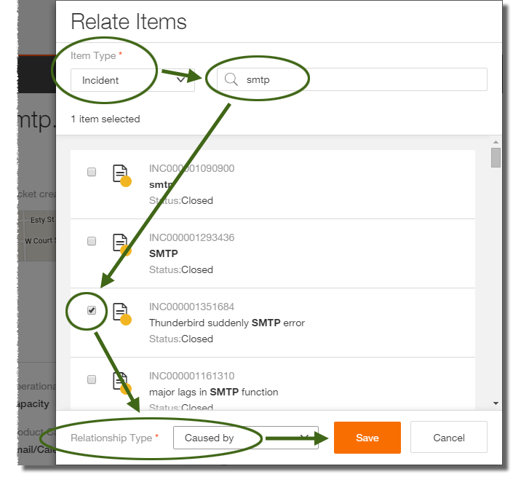
- Select a type from the Item Type dropdown list.
- Enter a keyword, title, or incident number in the Search field, then press Enter.
- Select the appropriate item from the list of results by putting a check in the box next to its icon.
- At the bottom of the Relate Items pane, select the appropriate entry in the Relationship Type dropdown list, then click Save.
A reference to the related record is added to the Related Items tab.

Send Email from a Work Order Record
- After opening the detailed view of the ticket, click the curved arrow icon near the incident title, then select Email this Work Order. A Compose Email pane will open.
- Enter the recipient(s) and include a message, if desired.
- Click Send when finished.

Resolve Work Orders
- After opening the detailed view of the ticket, you’ll see current status (New, Assigned, Pending, etc.) just below the title and incident number.
- Click the current status. An Update Status pane will open.
- Select the new status from the Incident Status dropdown list.
- Select the appropriate reason from the Status Reason dropdown list.
- Add a Resolution note (this field is required).
- Complete additional fields as appropriate.
- Click Save when finished.

Searching
The Smart IT Search function scans Remedy for records that contain a match for the word or phrase that you type in the Search field at the top of the screen. You can also augment your search by including special characters and Boolean expressions.
The Search field is located at the top right of the universal client. On mobile clients, Search is in the main menu.

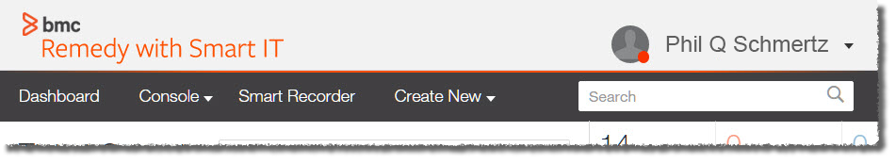

The Search function searches for matches to your query across the following record types:
- Incident tickets
- Work orders
- Tasks
- Service requests
- Knowledge articles
- People records
- Asset Management CIs

The search results include only information that you have permission to access.

Using Special Characters and Boolean Expressions
You can include special characters and Boolean expressions in your search, as explained in the following tables.

Special Characters
Special Character | Results | Example Search String | Example Results
" | Performs a phrase search on the terms enclosed in double-quotation marks (") | "firewall blocked" | firewall blocked her access  firewall blocking my access
, | Find requests that contain any of the specified words | firewall, blocking  "firewall, blocking" | firewall blocks access  firewall will block access  firewall is not working  try blocking his access
% | Wildcard to extend the search  Note: You do not need to use a wildcard to extend the search for word stems, such as "ed," "s", and "ing," because word stems are automatically included. | %fire% | backfire  file  firewall

Searches that start with a wildcard character are not as efficient as searches that use an exact phrase or a trailing wildcard. For example, searching for the term "%block" is less efficient than searching for either "block" or "block%".
You can use use Boolean expressions in your search. Boolean operators include parentheses (), AND, OR, and NOT. The Boolean operators must be specified in upper case; otherwise, they are treated as search strings.

Boolean Operators
Boolean Operator | Results | Example Search String | Example Results
AND | Find requests that contain all of the specified words and phrases | firewall AND blocking | firewall blocks access  firewall will block access
OR | Find requests that contain any of the specified words and phrases | firewall OR blocking | firewall blocks access  firewall will block access  firewall is not working  try blocking his access
NOT | Exclude the specified word or phrase | firewall NOT blocking | firewall is not working
( ) | group expressions | firewall AND (block, allow) | firewall blocking access  set up firewall to allow access

Filter Search Results
The Search function displays the search results in a list that is grouped by record type: tickets, knowledge resources, asset records, and people records. You can also apply filters to the list to help narrow the results and more quickly identify what you are looking for.
Where there are many results in a particular record type, only the first few will be displayed. You can display all results for a particular record type by clicking or tapping Show all for that type.
To narrow the results list by filtering the results, click or tap Filter at the top of the list of results.
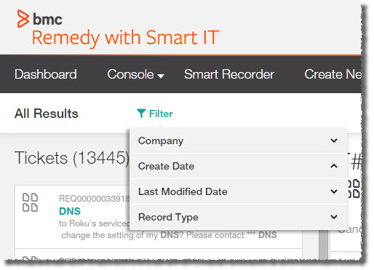

From the list that appears, click or tap the desired filter: Company, Create Date, Last Modified Date, or Record Type.
- For Company, enter the beginning of a company name, then press Enter. Select the desired company from the list.
- For Create Date or Last Modified Date, select Past 24 Hours, Past 48 Hours, Past Week, or Custom Range.
- For Record Type, select the desired type.
You can further refine your search by adding more filters.
You’ll see the filters currently in place listed next to the Filter icon in the All Results bar. Click or tap a current filter to remove it, or click or tap Clear All to remove all filters.
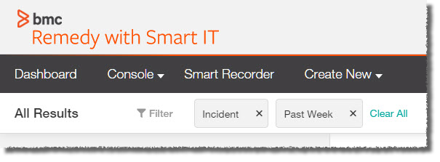

Bulk Actions
(Universal – web-based – client only)
In the universal client, you can perform actions on multiple tickets at the same time; for example, changing the assignee, updating the status, and following. Select the check box next to a ticket, or select the check box at the top left of the table to select all tickets.
Bulk actions are not available for mobile clients.
When you select one or more tickets in the Console, icons for several bulk actions appear.
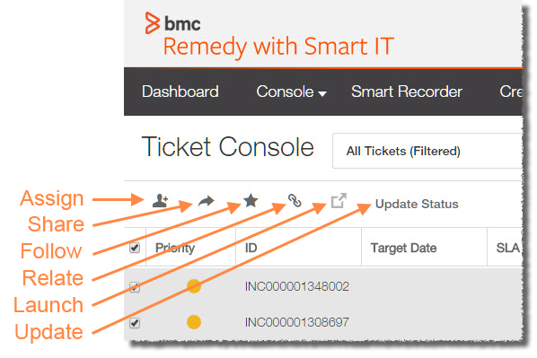
- Assign — Assign one or more tickets to an individual. For this action, the tickets you select must all be of the same type; for example, all work orders or all incidents.
- Share — Share one or more tickets with member of a support group.
- Follow — Choose one or more tickets for which you want to receive updates in the Dashboard.
- Relate — Link tickets together tickets or link tickets to other records. For this action, the tickets you select must all be of the same type; for example, all work orders or all incidents.
- Launch in new tab — For each selected ticket, opens details in a new tab.
- Update Status — Change the status of one or more tickets. For this action, the tickets you select must all be of the same type; for example, all work orders or all incidents.
After you perform a bulk action, the tickets remain selected so you can perform additional actions. Clear the check box in front of each ticket individually, or deselect all tickets.

