***Remedy***

***Work Order***

***User Basics***

***Classic View***



December 2016

# Viewing Work Order Management

The Overview console view allows users to respond, manage, or track individual or group work assignments from a variety of sources. For example, either you or the group you manage might receive work assignments from Word Order Management, Incident Management, Problem Management, and Change Management. From the Overview console, you can quickly get information about all your work assignments and perform the procedures that you use most often.

**Accessing the Overview Console**

When you first log in to Remedy, the default view is to show you the **“Overview Console”.** If you’re using multiple Remedy modules this is the view, we would recommend. If your not seeing the Overview Console you can update your defaults by:

1. Going to your main console view
2. Clicking on the **Application Preferences** link (left hand menus)

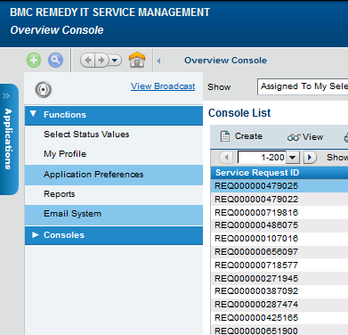

When you click on the Application Preferences link another window will pop open. On this window make sure you have the following fields filled out

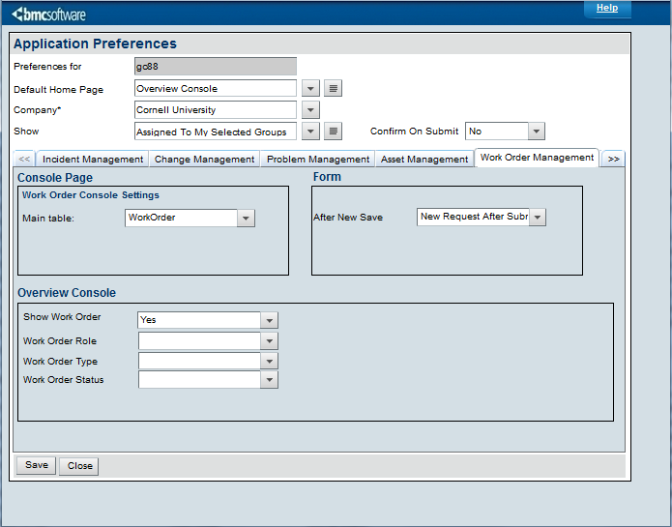

1. Default Home Page should say **Overview Console**
2. On the work Order Management tab also make sure that the **Show Work Order** field is set to **Yes**
3. Click **Save**

Now your default home page will be set to the Overview Console and you will be able to see Work Orders in that view.

# Work Order Management

A **Work Order** is an order received by an organization from a customer or client, or an order created internally within the organization.

At Cornell, we use work orders to request services or products whereas Incident Management is designed to deal with issues that need to be restored to normal functions.

If you’re working with multiple modules in Remedy (Incident, Work Order, Change, etc) then your default console view should be the **Overview Console.** In the Overview Console you can see any types of work requests:

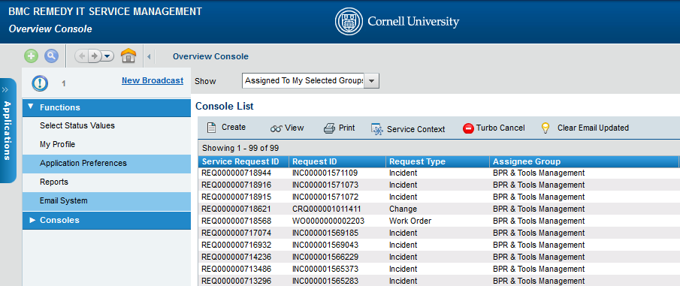

# If you would like to create a Work Order from the Overview Console you would click on Create and then select Work Order.

# 

# If you would like to access the Work Order console you can do that by going to Applications->Service Request Management ->Work Order Console

# 

Creating a work order without a template

# 

The following procedure describes the basic steps for creating a work order in the Best Practice view.

1. From the **Overview Console**, **choose Create >** **Work Order**
2. On the new Work Order form, select the customer and type in their NetID and hit enter to search. Create customer records if there is no NetID
3. *(Optional)* Enter your contact's name in the **Contact** field.
4. In the **Summary** field, enter a brief description.
5. *(Optional)* In the **Notes** field, enter the work order details.
6. In the **Service** field click on the pull down menu to select the general service that is appropriate for the request.
7. In the **Work Order Type** field, enter a type (for example, General or Project).
   1. You can classify work orders as **General** or **Project**, depending on the needs of your organization. This classification allows you to narrow the scope of work orders shown in the Work Order Console by using **Filter By > Defined Searches > Work Order Type**, or by setting an Application Preference. For example, you can set a filter to show only Project work orders, and then clear the filter to show all. If you set a preference for Project work orders, then you only see Project work orders every time you open the Work Order Console.
8. In the Request Manager section, select values for **Support Group Name** and **Request Manager**. You do not need to enter values if the assignments are already set unless you want to change them and you have the permissions to do so. See [Assigning work orders manually](https://docs.bmc.com/docs/display/srm90/Assigning+work+orders+manually).
9. In the **Status** field use this value to select the status of the customer’s request.
10. The **Status Reason** value is used to determine
11. Select the **Priority** to identify the importance you (as support staff) assign to the work order.
12. *(Optional)* From the Vendor Group menu, select the vendor.   
    If the vendor's ticket number is available, type it in the **Vendor Ticket Number** field.
13. Click the Categorization tab

* **Operational Categories**: They capture the *action* occurring in this incident. OpCats are used the following way in Remedy OnDemand:
* **Product Categories**: Describe the *product* involved in this case. If you know the product name, start to type it in the *Product Name* field, and the ProdCat tiers will backfill.

1. Click **Save**.

Viewing added customer data in the **Details** tab

If service requests are being populated by a user portal, then you may see additional tabs in your work order views. These **Details** tabs will capture additional information about the user’s request.

To view or edit the data shown in these tabs, click on the appropriate tab and update accordingly.

# 

# Functional roles in Work Order Management

Work Order Management includes two functional roles — work order manager and work order assignee. Functional Roles provide additional capability to the users, not based on permission group

## Work order manager- The work order manager is responsible for the quality and integrity of the work order management process.

## Responsibilities and activities -In large companies, the work order manager's main responsibilities usually involve planning and oversight. However, in small companies the work order manager might also function as the work order assignee who performs the tasks for the work order. In the Work Order Management application, users with either the Work Order Manager or Work Order Assignee functional role can be assigned to individual work orders, so you can choose how to apply these roles in your organization.

## Work order assignee -Work order assignees are responsible for planning and implementing assigned work orders. They are usually people with specialized abilities in the support department of larger organizations. The work order assignee might be working actively on the work order, or coordinating the efforts of other groups or individuals working on tasks, if necessary.

Assignee activities and responsibilities include the following:

* Gathering appropriate information based on the work order assigned
* Providing status updates to requesters on request
* Plan the task schedule
* Executing the tasks that make up a work order
* Reviewing all completed tasks, if more than one work order assignee helped complete the overall work order

## How to create a work info entry and read it

To add updates to the incident, click on the **Work Detail** (red #1) tab. If you want to enter information or updates about the incident you can add that information in the **Notes** field (red #2). Attachments can also be added by clicking on the folder icon next to the **Attachment** field, this will allow you to browse to search for documents you may want to add to the incident. To delete an attachment, click on the icon that looks like a paper/eraser and that will remove the attachment. The **More Details** drop-down (red #3) can be selected to show space for more attachments and the work info type. Notes can be **Locked** (red #4), which prevents any further edits. The **View Access** can also be restricted (red #5).

This is not in use now, but when Remedy OnDemand has a customer-facing interface, this will determine what updates the customer can see.

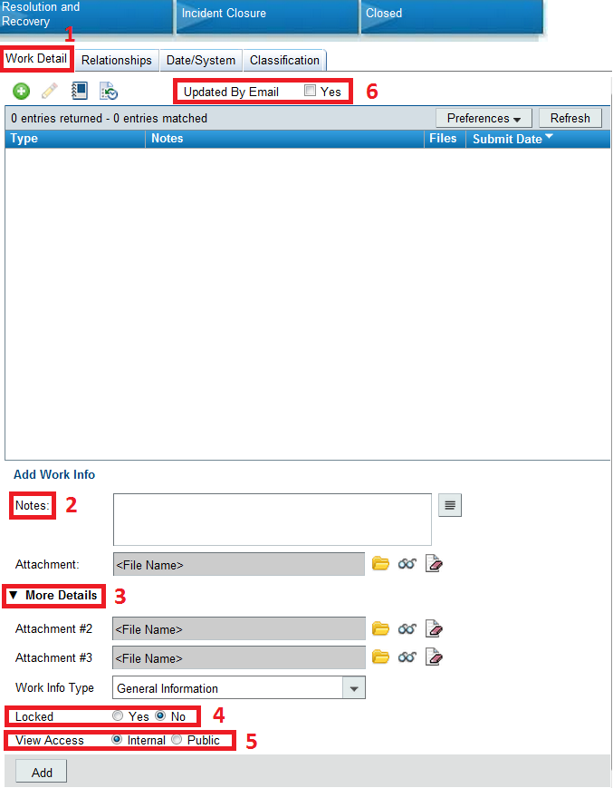

The **Updated By Email** flag (red #6) also resides on the **Work Detail** tab. This will be checked if someone has emailed into the incident.

## 

## How to send email from the Work Order Request

When viewing a Work Order click on the email function which is found under **Functions > Email System**

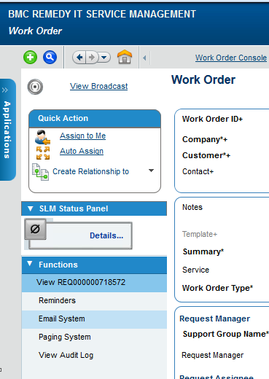

The email application will pop up:

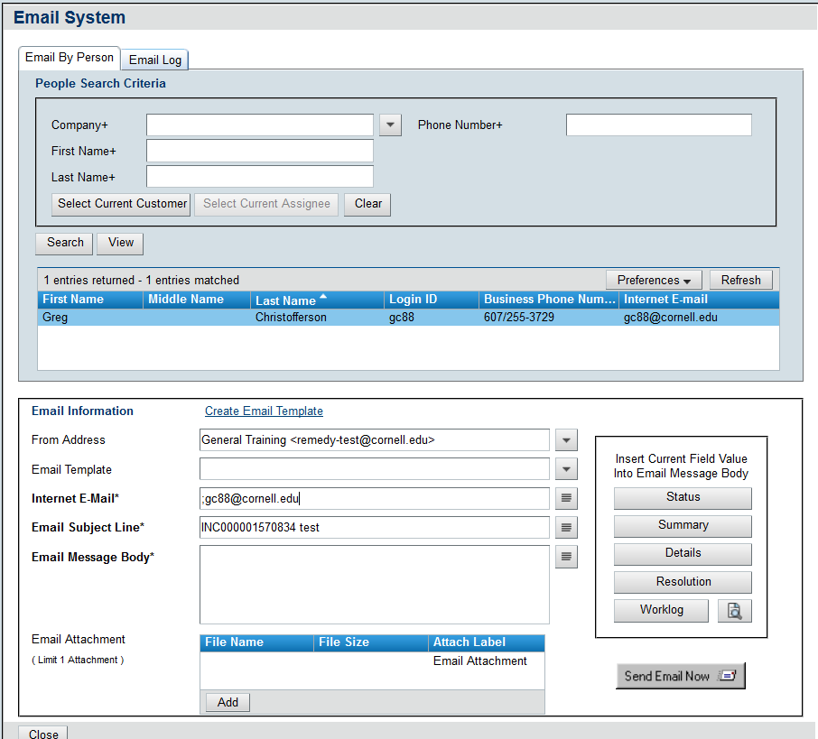

In this form, you can write your response in the **Email Message Body** section and then click **Send Email Now**. You can also use an **Email Templates.** Individuals can create their own templates, and those with special privileges (supervisors) can set email templates that entire groups can use. Select these from the drop-down, and they will auto-fill the **Email Message Body** with preset text.

More than one template can be used per message: they fill in before or after the previous template. The email you send through Remedy will be logged as a work info in the corresponding Incident. The customer will receive the email with the message you have typed. If they reply to the message it will be added to the appropriate incident as a work info.

## How to create Relationships between two incidents

Relationships tie cases together; relationships can be viewed in the **Relationships** tab as seen below.

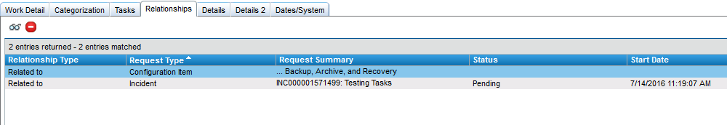

To create a relationship, select **Create Relationship to** and choose **Incident, Work Order, Configuration Item or Infrastructure Change** from the drop-down menu.

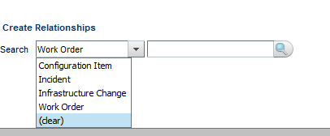

If you know the number of the ID number that you would like to relate, you can enter it in the search field. If you don’t know the item number then click on the magnifying glass to search

Choose **Use Advanced Search** from the top right of the search window that appears.

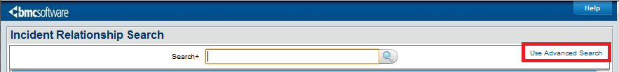

From the advance search select the criteria to narrow down your selection and then highlight the items you want to relate and then click the **Relate** icon.

