Remedy MyIT
User Basics

December 2016

MyIT Overview
MyIT is a self-service IT service management portal that allows users to submit, manage and resolve individual or group-related requests to optimize productivity and enhance customer service.

Accessing MyIT
To access MyIT go to: https://cornell-myit.onbmc.com
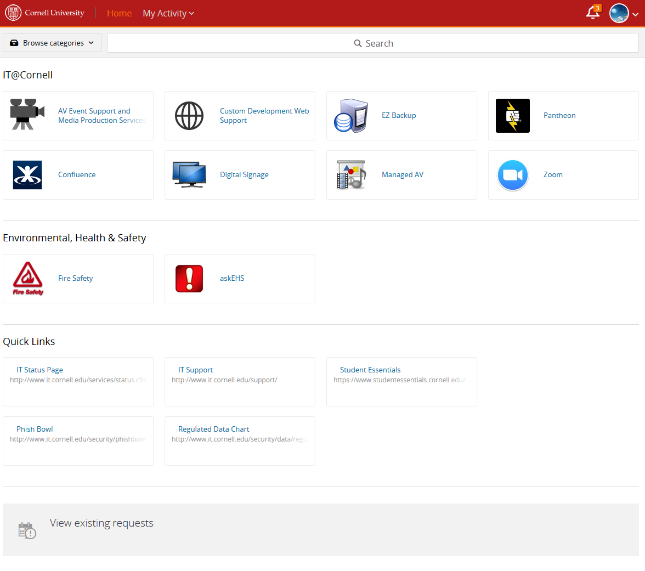

MyIT Navigation
The default home page of MyIT is broken into four sections:
- Navigation: here you can access your profile, search or see request activity (#1 below)
- Service Request Forms: these are the forms that are available through MyIT (#2 below)
- Quick links: These links will take you to valuable web resources (#3 below)
- View Existing Requests: will take you to your existing requests (#4 below)

4
3
2
1

I. Navigation
The Home link takes you to the default view of the MyIT service landing page
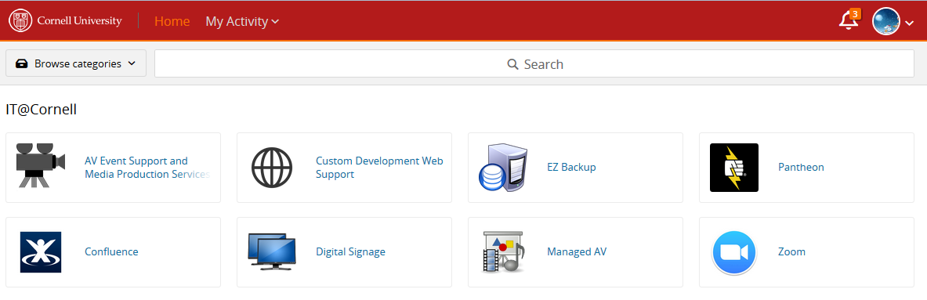

The My Activity link provides you with insight into:
- All Activity: shows all requests and approvals
- Requests: shows the requests you have submitted, both through MyIT or by email
- Approvals: If your organization uses Change Management, approvals can be viewed here.

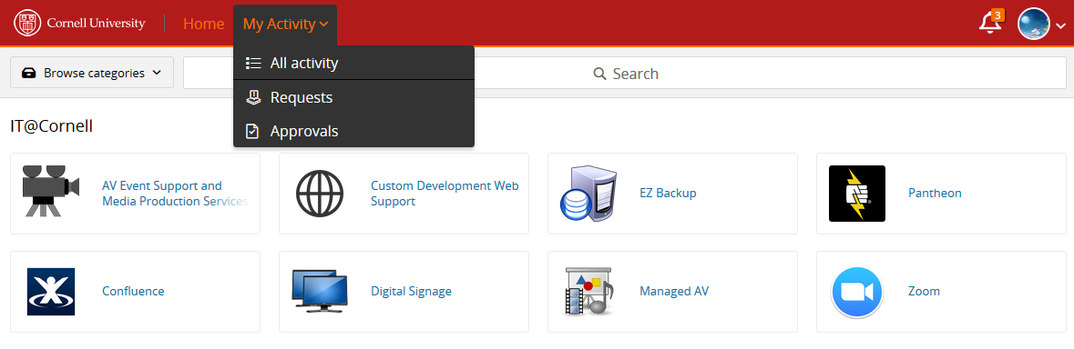

My Activity -Requests: When you click on Requests, you will be able to see all of the request for support that you have made, either by email or through MyIT.

The request activity will show:
- The most recent activity (on top)
- When it was last updated
- Request status
- Any Comments that were added by either the user or by support staff
- Where users can provide updates to the ticket by adding new comments
- A way for users to either search or filter request
- Request again is available by opening the request and selecting Request Again

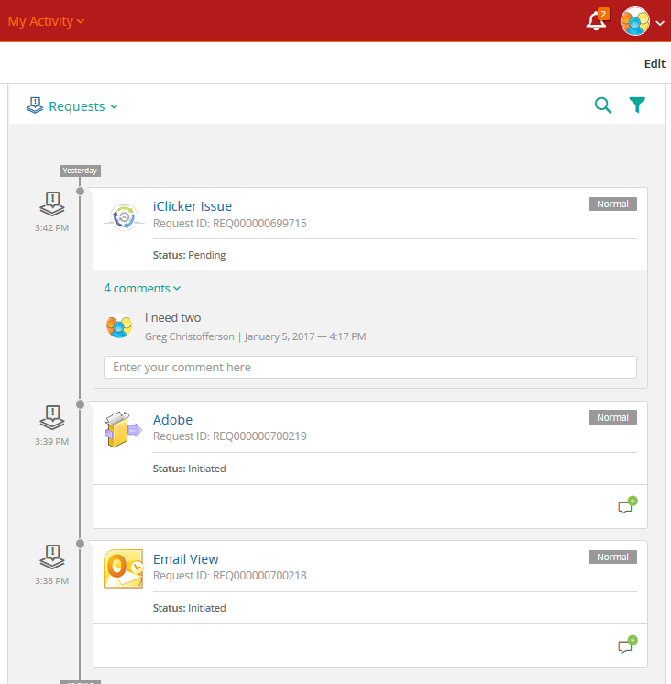
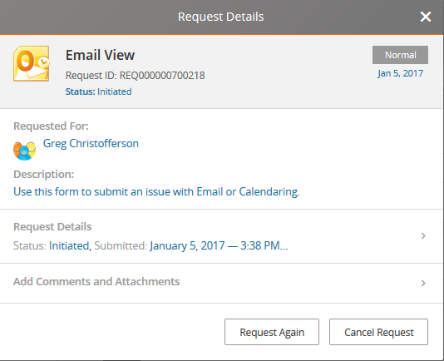
7

2
3

4

5
6
1

My Activity -Approvals: show any requests that require an approval. Currently on Change Requests require approval in Remedy. From this window you can click Approve, Reject or put the request On-Hold. You can also see more information about the Change Request by clicking on the blue CRQ number.

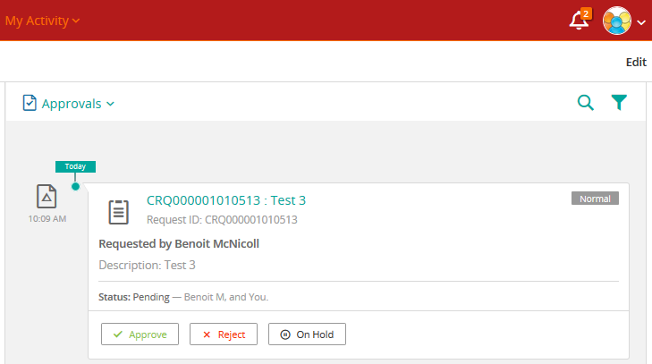

Notifications: through MyIT notifications you can see any notices that require approvals. Through this feature you can approve, reject or place Change Requests On-Hold. You can also see more information about the Change Request by clicking on the blue CRQ number.
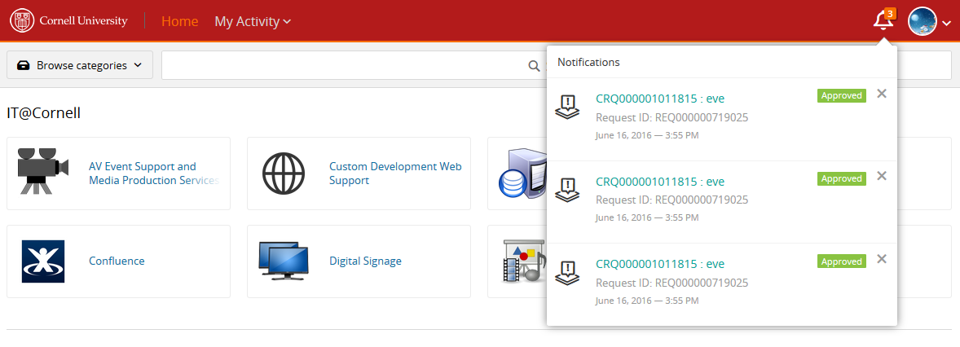

Signed in as: shows you MyIT profile, from here you can update a photo, see your default settings (email and phone numbers are not editable through this feature), or Sign out.
*Note Under this feature is a settings link, the options under this link are not active.

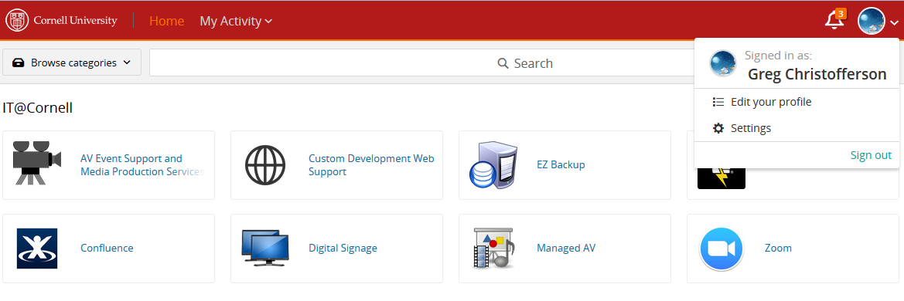

Browse Categories: allows users to type in (minimum 3 letters) service names or aliases to quickly find Service Request forms.

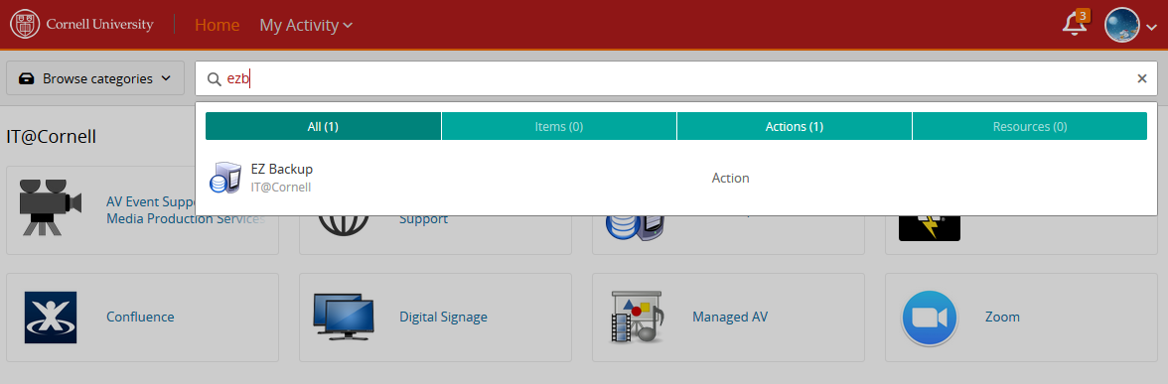

II. Service Request Forms
Service Request forms become available as Cornell organizations Service Owners/Service Managers work with the Remedy Service Management Team. Over time users will see more service request forms get added to MyIT.

Service request forms are available for IT and Non-IT departments on Campus.

Viewing a service request form: to submit a ticket for service, click on the service icon.

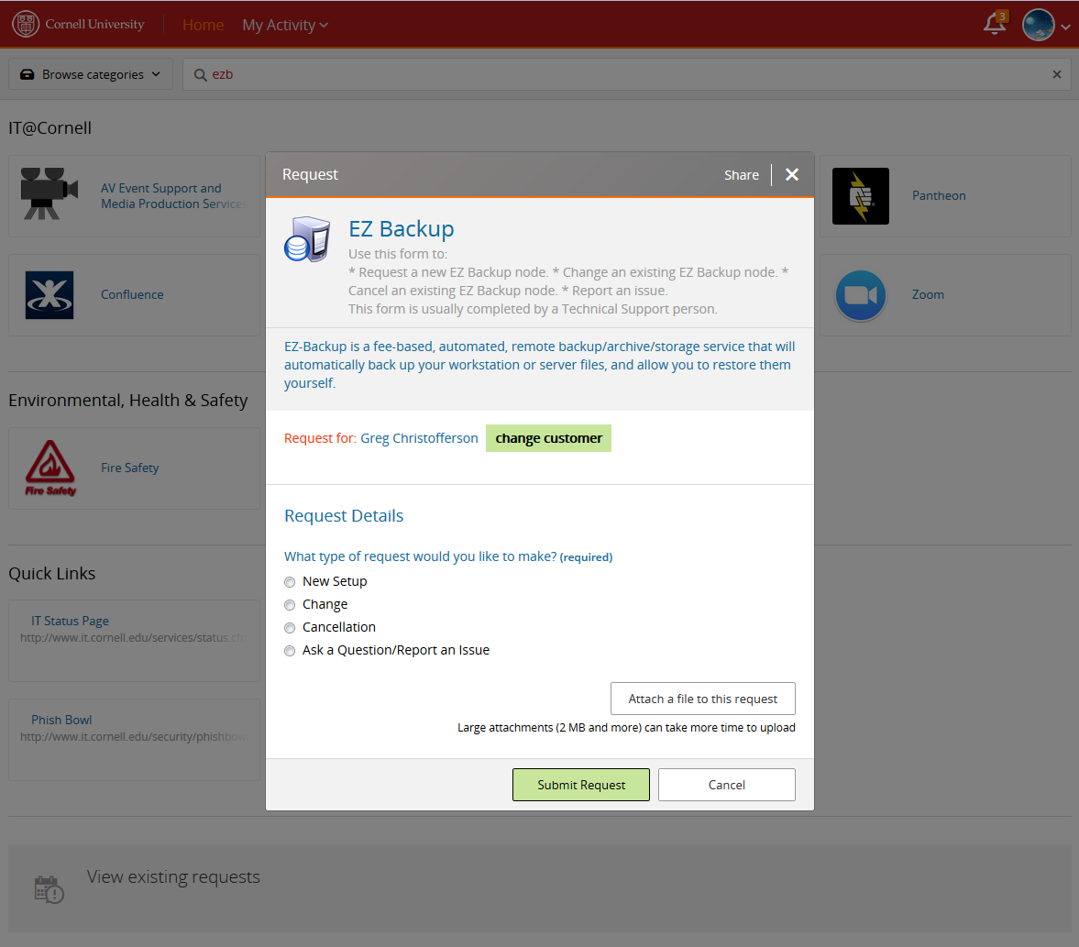

Request forms are designed by the Service Owners/Service Manager, and can vary in design, featured and fields, however all forms maintain some consistency.
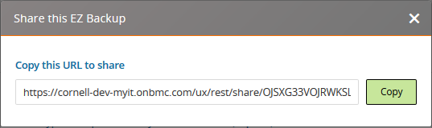
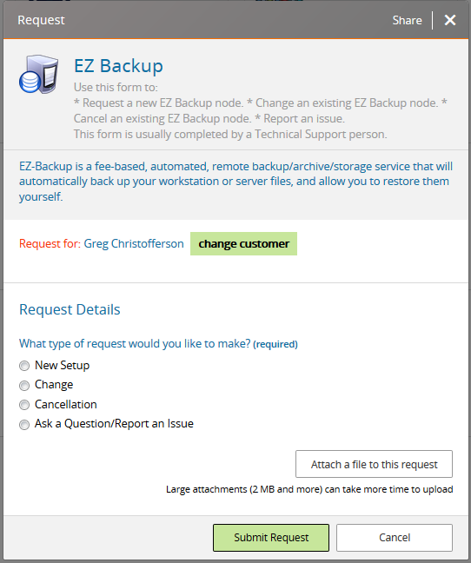
7
6
5
4
31
2
1
- Share allows a user to copy the URL of the form to share with others

- Outlines the service name and instructions

- Outlines the service descriptions

- Outlines who the request is for, if you want to request for someone other than the user listed, click on Change Customer

- Shows the request details, the options here may be different depending on what the Service Owner have designed.

- Ability to attach a file

- Submitting or cancel the request

III. Quick Links

Quick links: provides valuable web resources available to MyIT users. To view the quick links, click on the link.
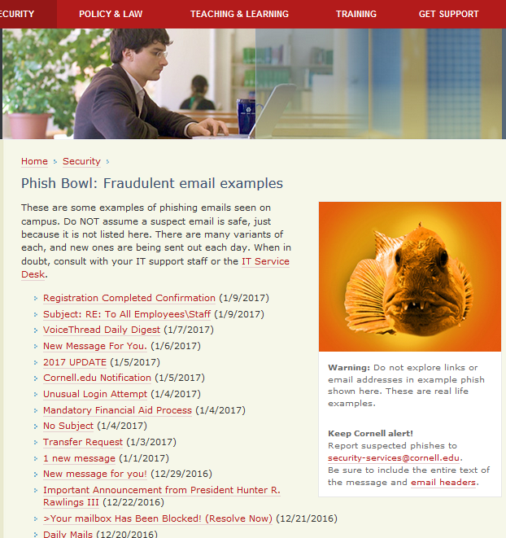

IV. View Existing Requests:

Clicking on View Existing Requests will take you to your existing requests as described in the Navigation - My Activity section

