Collaboration Services

Remedy Classic Users Guide

Oct 28^{th,} 2016

Remedy Production Environment URL: https://cornell.onbmc.com

Remedy Support Email: remedy-admin@cornell.edu

Contents
The Overview Console Page 3
Incident Creation 6
Existing Incident Operation 8
How-To Procedures 10
Email Templates 15
Creating Email Templates 15
Remedy Tips & Preferences 17
Customer's Incidents 17
Application Preferences 17

The Overview Console Page
The Overview console view allows users to respond, manage, or track individual or group work assignments from a variety of sources. For example, either you or the group you manage might receive work assignments from Asset Management, Incident Management, Problem Management, and Change Management. From the Overview console, you can quickly get information about all your work assignments and perform the procedures that you use most often.

Accessing the Overview Console
When you first log in to Remedy, the default view is to show you the “Overview Console”. If you’re using multiple Remedy modules this view will be allow you to see all the customer requests from a single console.

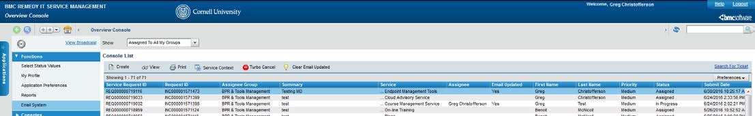

When you log into Remedy if your default view is not the “Overview Console”, then you can access it by going to the Applications tab, then going to Foundation Elements and then to the Overview Console.
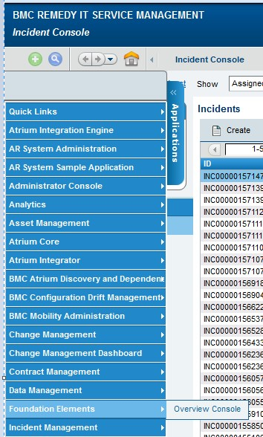

1

2

3

This section illustrates the functional areas of the Overview console and describes what you can do in each of the functional areas.
The navigation bar at the very top of the console helps you move around.

The Green + is a shortcut to create a new case, and the “Blue Magnifying Glass” is a shortcut to search cases. They can be used in place of the individual links for each function on the left of the IM console when the main links are not on the screen (for example, when viewing an individual incident).

The forward and back buttons take you between your previous (and next) views if available. The Home Icon takes you back to the Overview Console screen.

Clicking the Down Arrow next to the back/forward buttons gives you a jump list of recently-viewed items that you can select to view/go to.

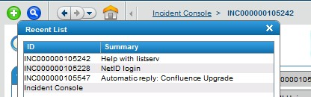

View Broadcast Opens the broadcast dialog box, from where you can view, create, modify, and delete broadcasts

The Show field (see #1) provides a filter by which you can manage the contents of the Console List table.
The choices are:
- Submitted by Me — Shows all records submitted by you.
- Assigned to Me — Shows all records assigned to you.
- Assigned to My Selected Groups — Asks you to select one of the groups to which you belong, and then displays the records assigned to that group.
- Assigned To All My Groups — Displays the records assigned to or requested for all of the support groups to which you belong. The Company field restricts the criteria that you choose in the Show field for the selected company. This helps you manage the number of records returned by the Show field.
- Watch List: allows you to see any records that you have saved as part of your watch list.

The navigation bar features (see #2) allow users to:

- Create: Allows you to create a new Incident, Infrastructure Change, Problem Investigation or Work Order. Although other options exist under create (e.g. Known Error, Solutions Database, Purchase Requisition, and Release) they are currently not active modules within Remedy.
- View: Displays a form containing detailed information about the selected record in the Console List table.
- Print: Displays a report of the record contents that can be printed.
- Service Context: The Service Context icon is only available on the Overview console when you open the Overview console from the Applications list.
- Turbo Cancel: is a feature used to remove (or cancel) spam
- Clear Email Update: clears the "Email Updated" flag for cases where new emails came into Remedy.
- Preferences: This button allows you to set preferences for the console list table. You can remove columns, set refresh intervals, reset and save your preferences
- Logout: Click Logout to exit the application (see #3).
- Refresh: Refreshes the data in the tables.
- Global Search: Type in a word or a phrase in the search area, and the application will search across multiple forms for records that match your input.
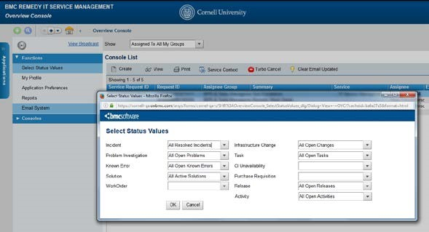

From the left hand menu
Functions
allows you to:

- Select Status Values — see only those records in a certain state, which you specify from the Select Status Values dialog box.
- My Profile — Set/view your profile.
- Application Preferences — set your program preferences and options. This function is also available from the application console.
- Reports: allows you to create ad-hoc reports
- Email System: allows you to email customers
- Consoles features are not being used by our version of Remedy.

Incident Creation
Create an “open” Incident
Cases can be created from Fields we need to fill out are outlined in Red.
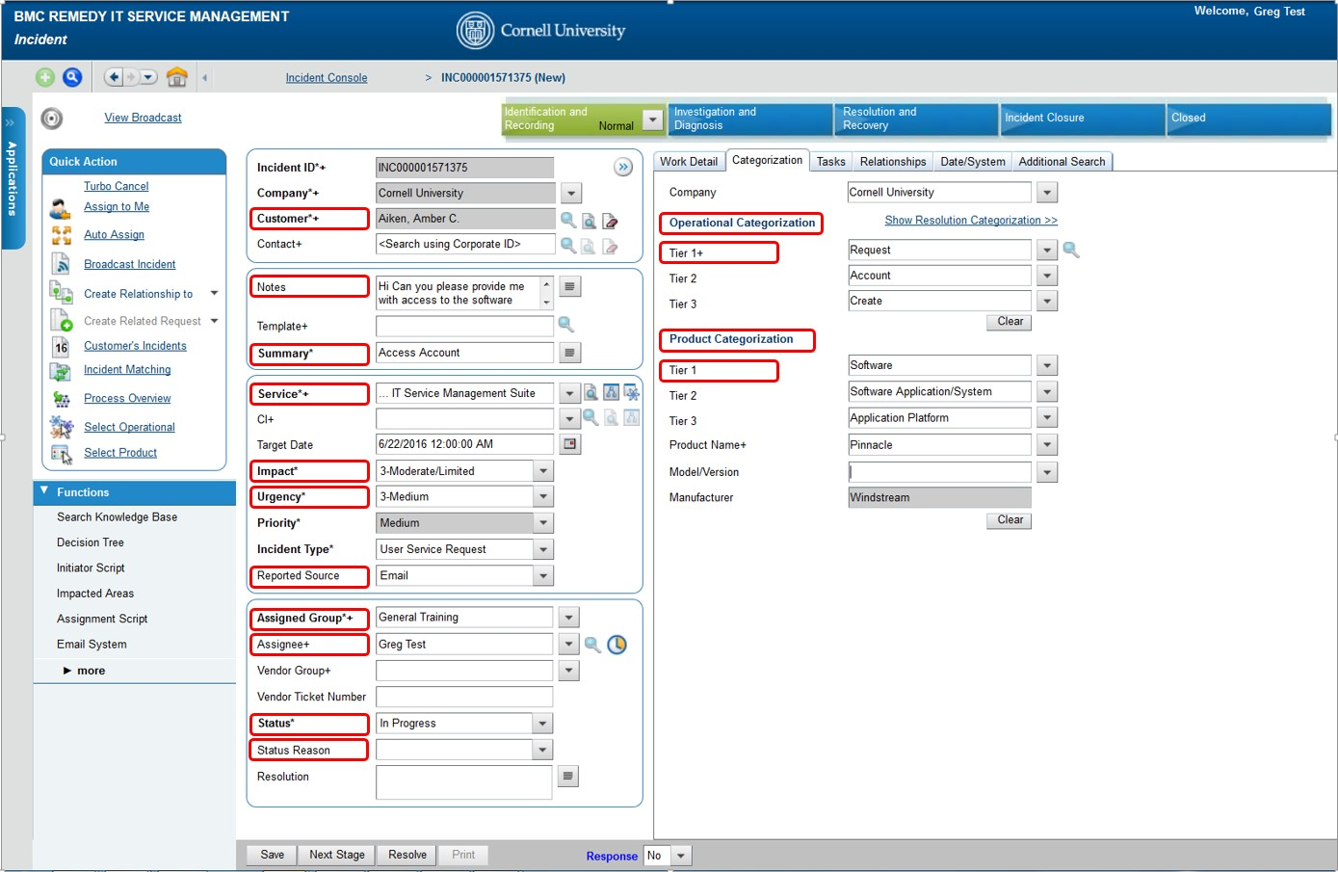

These include:
- Customer: Type in their NetID or name and hit enter to search. Create customer records if there is no NetID.
- Summary – This is taken from the Subject line in the email. When manually creating an incident use this as a short description of the request.
- Notes – The body of the email is found in the notes. When manually creating an incident you can use this area for more details on the request or trouble.
- Service: Captures the general service the person is calling for assistance/information about (email, accounts & passwords, etc.)
- Impact & Urgency: Combined, these form priority. Impact refers to number of people affected, urgency deals with how critical the problem is for those affected. For customers marked as VIPs (next to the Customer field), urgency and priority increase by 1.
- Reported Source: provides options to define how the request was submitted
- Assigned Group: You can search for assigned groups by typing all or part of the name.
- Assignee: This is required to set a case as pending or resolved.
- Status – Use this for indicating the status of the Incident.
- Status Reason – Currently only used when “Status” of pending or resolved is selected.
- Operational Categories: They capture the action occurring in this incident. OpCats are used the following way in Remedy OnDemand:

  - Tier 1 – The “Verb” or “Action” as to why the user is calling
  - Add
  - Backup
  - Failure
  - Request
  - Tier 2 – Describes the “What” the user is calling about
  - Account
  - Server
  - Computer System
  - Tier 3 – Describes the issue further (if needed)
  - Access
  - Account
  - Database
  - Commission or Decommission

- Product Categories: Describe the product involved in this case. Search for the appropriate product in the Product Name field, and the ProdCat tiers will backfill. See

*NOTE! As soon as you click the Save button in the Create Incident form, the information is saved, the customer gets an acknowledgment that the incident has been created, so don't click Save until you're really ready to save the incident and move on, and be sure you have the correct NetID in the NetID field or someone will get a notification and have no idea why

Existing Incident Operation
How to search incident?
From the left side menu you have the option of clicking on “Search Incident” to search on the standard fields or if you would like to search the “Work Info”, “Relationship” or “Assignment Log” locations you can click on the Advanced Search link.
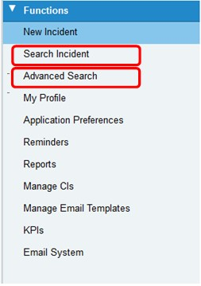
The default search view is very similar to the new case creation view. You can search by any field, or by fields on the Classification tab.

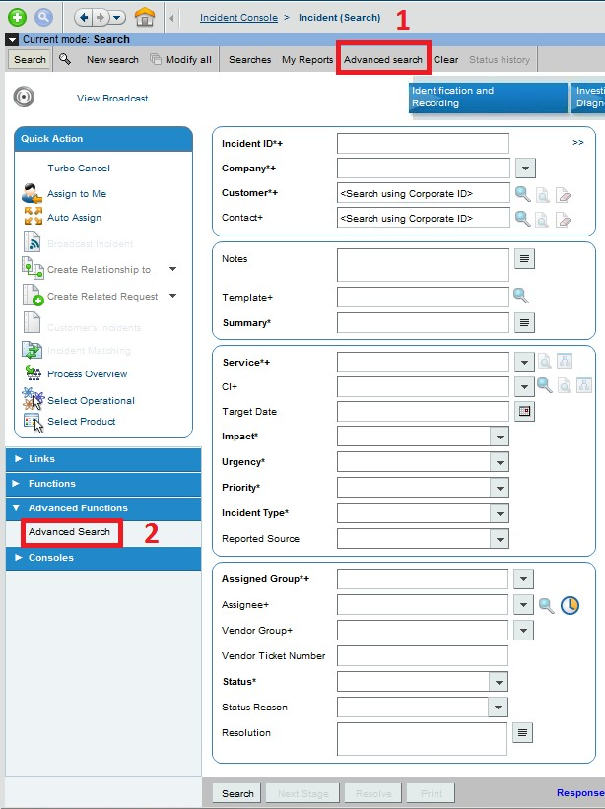

The left side Advanced Search link (red #2) allows you to search by work info or relationships. The top
Advanced Search link (red #1) provides a space to enter search strings with logic operators (less useful).
How to create a work info entry and read it

To add updates to the incident, click on the Work Detail (red #1) tab. If you want to enter information or updates about the incident you can add that information in the Notes field (red #2). Attachments can also be added by clicking on the folder icon next to the Attachment field, this will allow you to browse to search for documents you may want to add to the incident. To delete an attachment, click on the icon that looks like a paper/eraser and that will remove the attachment. The More Details drop-down (red #3) can be selected to show space for more attachments and the work info type. Notes can be Locked (red #4), which prevents any further edits. The View Access can also be restricted (red #5).

This is not in use now, but when Remedy OnDemand has a customer-facing interface, this will determine what updates the customer can see.

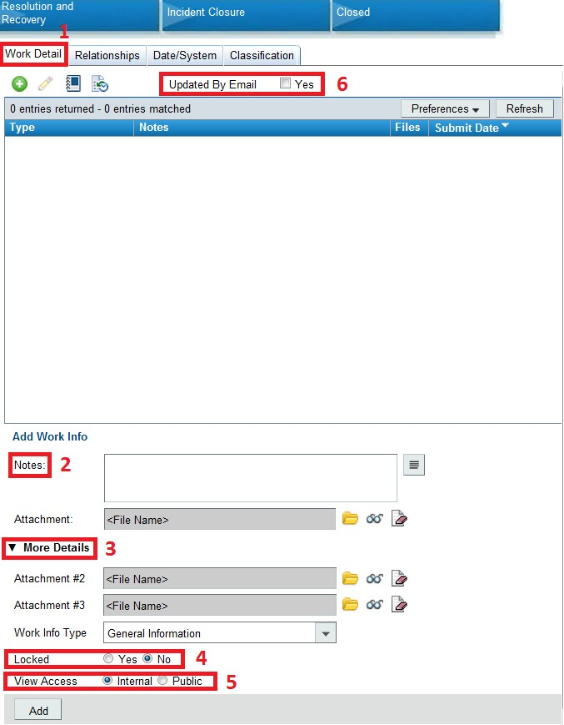

The Updated By Email flag (red #6) also resides on the Work Detail tab. This will be checked if someone has emailed into the incident.

How-To Procedures
How to assign an incident
- Open the Incident that you wish to work on.
- Select or type a support group.
- If you know the person to assign it to, then select an assignee.
- Save the Incident.
How to change customer information
- Click the “Clear Customer Information” icon
- Now click on the button to get the expanded view of the notes.
- Scroll to the bottom of the notes and identify the customer from the email header. Also take note of the customers email address. You may want to copy it to the clipboard.
- Close the expanded notes view.
- a. Type the persons NetID in the NetID field and hit return on the keyboard.
b) Click the modify button found just under the Desk Location field.
- Paste the new email address in place of the one in the existing record.
- Save the customer record.
- Save the incident.
- Click yes to the resulting dialog
How to view attachment
- Double-click on the work info.
- click on “View” attachment icon in the Work Info area.
How to send email from the incident record
When viewing an individual case, the email function is found under Functions > Email System (red #1).

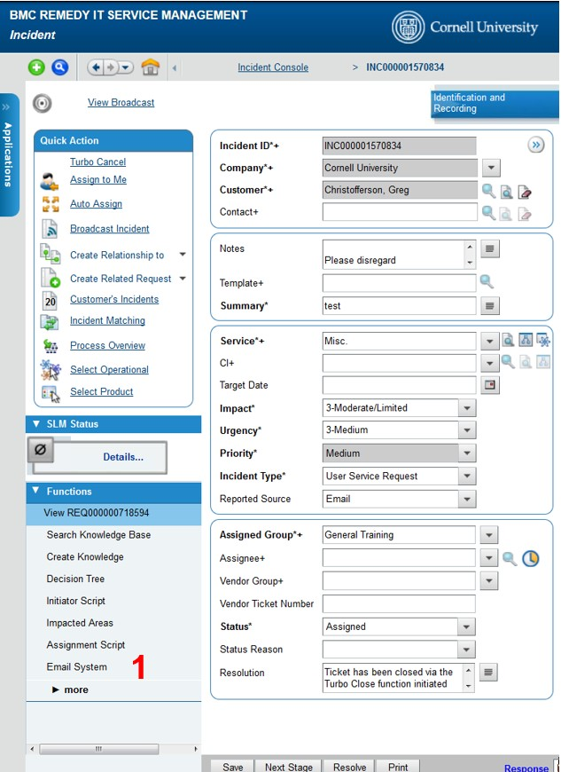
Click on Email System and the email application will pop up:
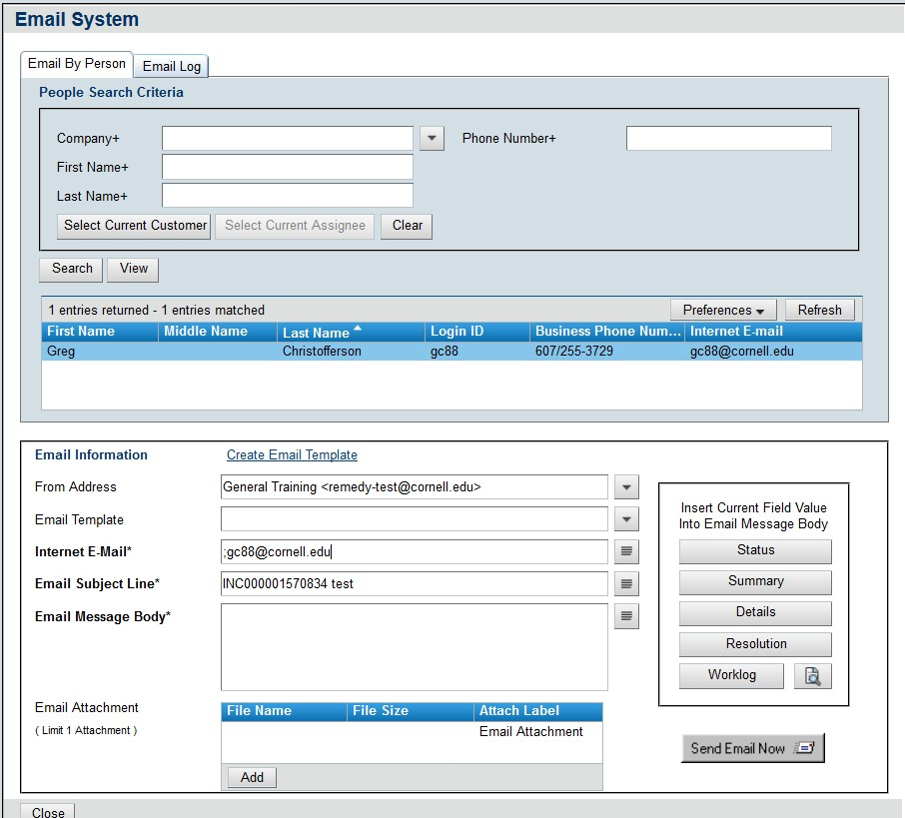

In this form, you can write your response in the Email Message Body section and then click Send Email Now. You can also use an Email Templates. Individuals can create their own templates, and those with special privileges (supervisors) can set email templates that entire groups can use. Select these from the drop-down, and they will auto-fill the Email Message Body with preset text.

More than one template can be used per message: they fill in before or after the previous template. The email you send through Remedy will be logged as a work info in the corresponding Incident. The customer will receive the email with the message you have typed. If they reply to the message it will be added to the appropriate incident as a work info.

How to create Relationships between two incidents
Relationships tie cases together, and Remedy OnDemand has a few different relationship types:
- Related To: To link incidents that are related.
- Original Of: This creates a parent-child or master-case relationships. You must start with the parent case, search for the child case, and set the relationship type for the child case as Original Of. This means the parent case you are currently working with will be the original instance of the child.
- Duplicate Of: Allows for marking duplicate cases.

Relationships can be viewed in the Relationships tab as seen below.

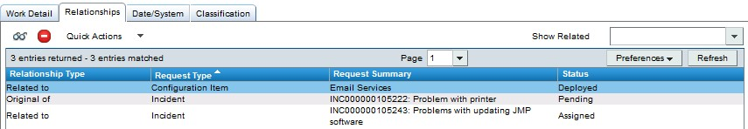

To create a relationship, select Create Relationship to (red #2) and choose Incident (red #3) from the drop-down menu.

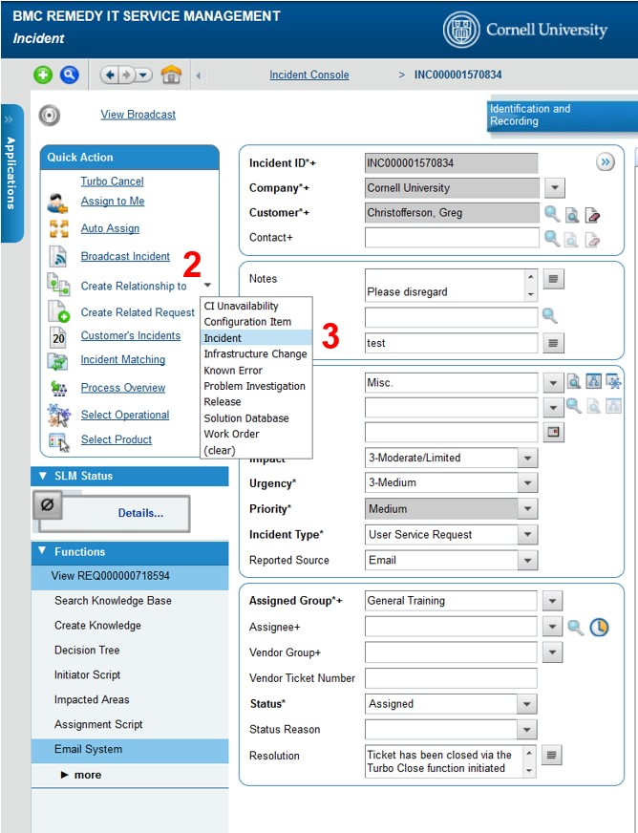

Choose Use Advanced Search from the top right of the search window that appears.
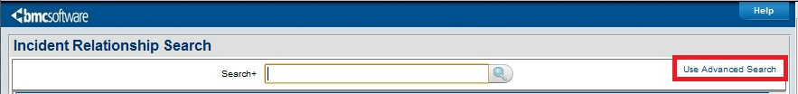

Enter the Incident ID number and search (red #1), or use other criteria. Make sure the right incident you want to relate is selected (red #2). Select the appropriate Relationship Type, (red #3) and click Relate.

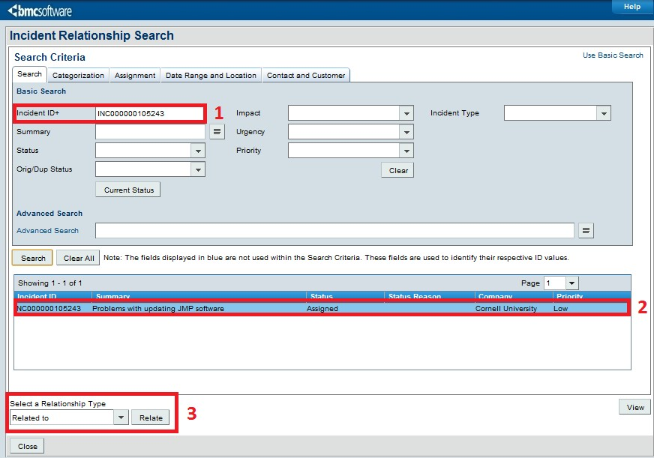

Notes on special relationships (Original Of & Duplicate Of)

- Original Of should be used for parent-child or master-case relationships. When the original (master or parent) is resolved, the child cases will be resolved with them. Notification emails should still be sent to customers individually.

- Duplicate Of relationships are for duplicate cases. They create case dependencies as well--the original case where you set another as a duplicate of it becomes the Original Of the other. The other case is resolved when you resolved the original as well.

How to resolve an incident
Before resolving the incident all notes regarding the work done should be entered.

To resolve an incident you will need to change the status to Resolved and then add the appropriate Status Reason.

Underneath the Status & Status Reason is a field called Resolution (red box).

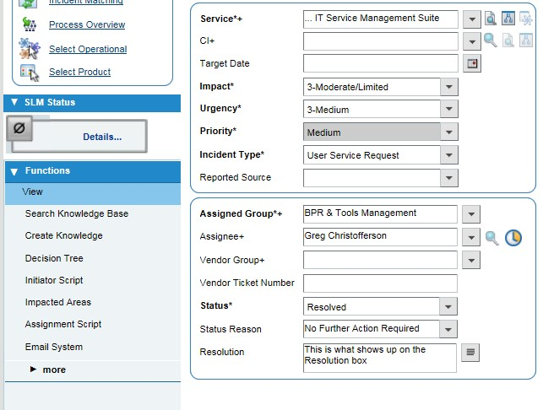

The text in this field is sent to the customer in the resolution email notification. Phrase this in full sentences, using language the customer can understand, and keep it professional. The notification looks like this:
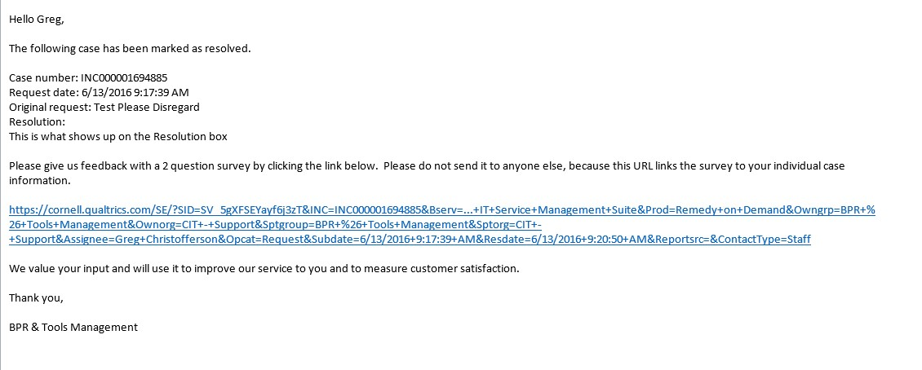

*It is very important to “Resolve” incidents and not “Close” them for incidents you worked on. (Customer cancelled and “Spam” email are handled differently)
The system with automatically close incidents after it has been resolved for 2 weeks. A “Resolved” incident can easily be re-opened and additional notes added.

Email Templates
Email templates let you insert custom text into emails without typing it out every time or copy/pasting it into the email message field. Templates are used to respond to a common question or problem.

You can also create individual templates that are only available to the person who created them.

Creating Email Templates
In The Incident Management Console, select Manage Email Templates. The Email Template form will open.

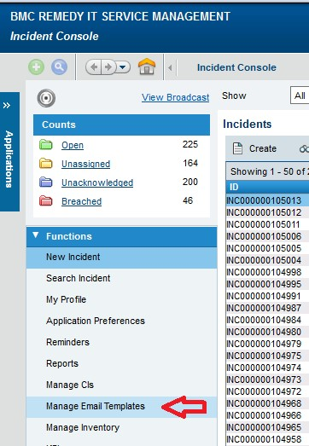

Enter an Email Template Title for the template and the template text in the Message Body field, both at the bottom of the Email Template search/create window.

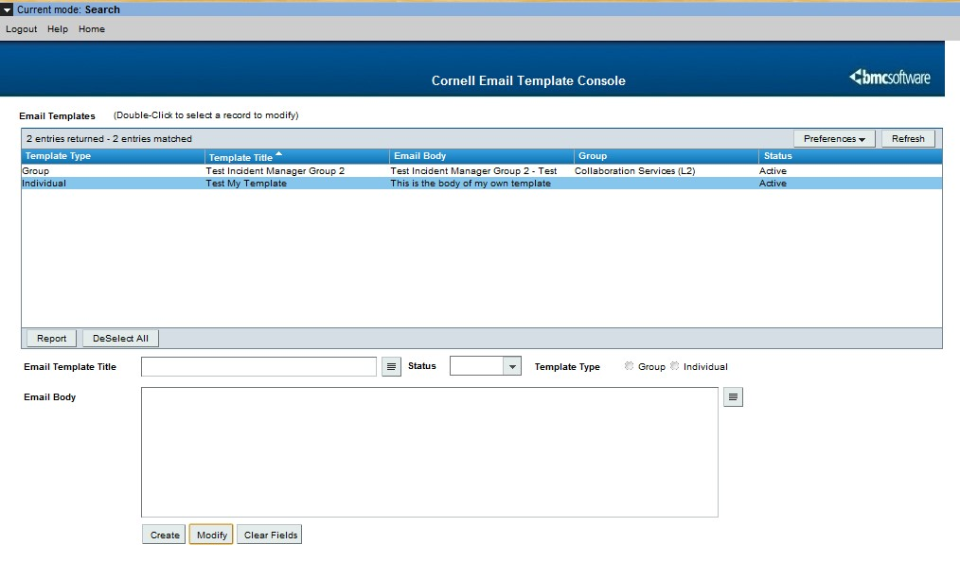

Before saving, choose whether this is a Group or Individual template. Individual templates only show up for the person that creates them. Group templates show up for everyone in the group.
Last, select the Status: set this to Active so you can use it. When finished, click Create.

You can come back to this Manage Email Templates section to modify/delete templates later on.

Remedy Tips & Preferences

Customer's Incidents
When working cases, it's often useful to see what other open cases they have (or might have). Remedy OnDemand makes this fairly easy if you have a customer's current case open. In the Quick Actions sidebar, select Customer's Incidents.

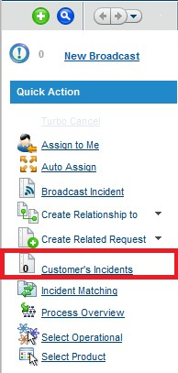

Application Preferences
Setting the default view to be the Incident Management console:
- Click on the Applications tab and then move your cursor down to the Incident Management and select Incident Management Console
- Next, under Functions, click on Application Preferences

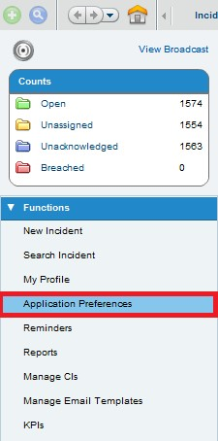

- On the window that opens up, change the “Default Home Page” to the Incident Management console (red #1) instead of the Overview Console.
- Set “Show” to Assigned To All My Groups (red #2)
- Select Assignee under “Role” (red #3)
- In the field labelled “After New Save” change the value to Modify Request After Submit (red #4)this allows you to continue working with a case after saving/submitting, instead of being presented with a blank new case window.
- Click Save and then Close

