SEVIS Event Type

There was no retrofit here. All I did was navigate to page shown below and confirm the existence of the new fields/page layout as described in the Bundle 38 Campus Community release documents.

Set Up SACR > Product Related > Campus Community > SEVIS > Common Definitions > SEVIS Event Types

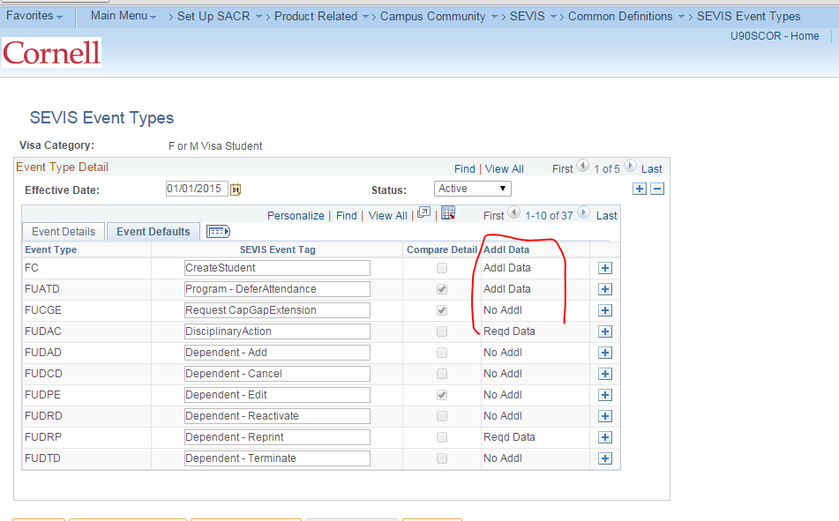

STDNT_AID_ATRBT.FA_SS_INQ_SECURITY

There was no retrofit work here -- all I did was confirm the new field is available for Pop Update as expected.

Added the record to my Population Update security

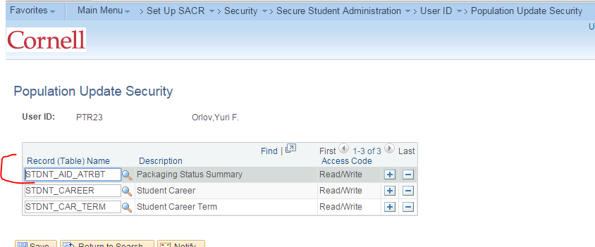

Confirmed the new field FA_SS_INQ_SECURITY exists in the Population Update Setup
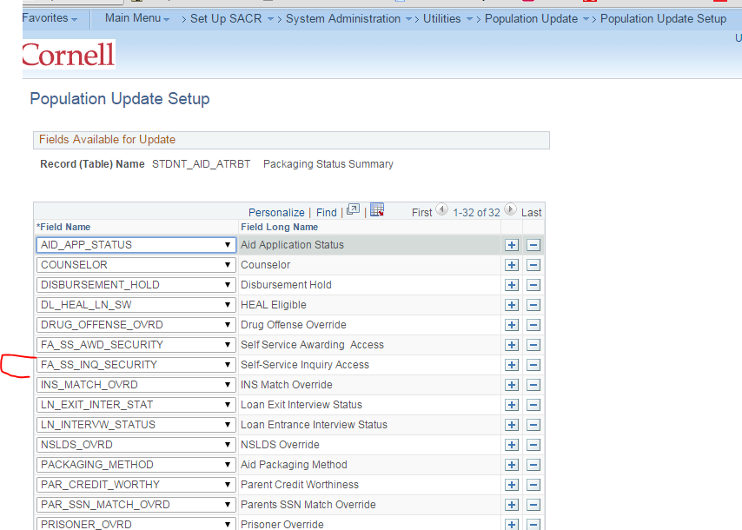

Process SEVIS Alerts – F/M

ccsevlib.sqc was retrofitted.
Referred in ccsevcmp.sqr:
Campus Community > SEVIS > F/M Alerts > Process SEVIS Alerts - F/M

outcome: Process runs to Success; see screenshots below

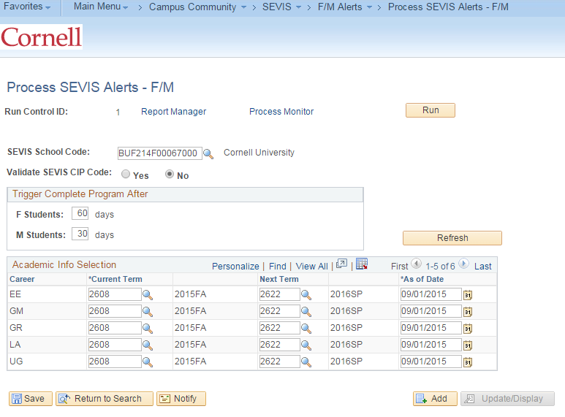

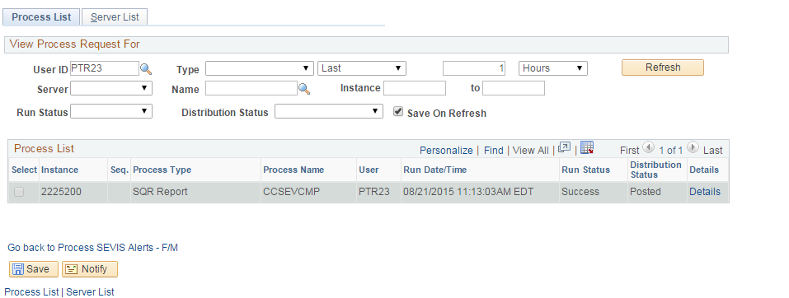

Process SEVIS Alerts - J

ccsevi20.sqc was retrofitted
Referred in ccsevds.sqr:
Campus Community > SEVIS > J Alerts > Process SEVIS Alerts – J

No values appear to be available for the Program Number field …. I am guessing Cornell may not use this process?

